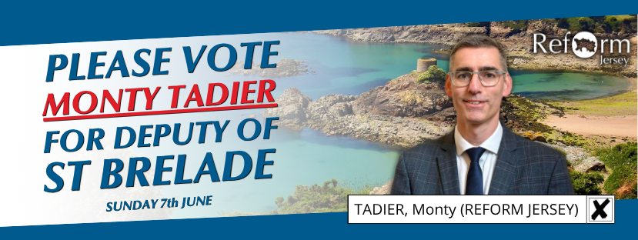
A STRONG VOICE FOR ST BRELADE

Dear Voter,
For the past 18 years, it has been my privilege to represent the people of St Brelade in Jersey’s national parliament. In all that time, I have worked hard to ensure I am the kind of representative you deserve: someone who listens, who will speak up on the important issues and who will take action when needed.
I am not one of those candidates you only hear from at election time. I have been an active States Members, taking on leadership roles in Scrutiny (Economic and International Affairs Panel), International Parliamentary groups (Assemblée Parlementaire de la Francophonie) as well as working with members across the assembly on theme focused sub-panels, into critical policy areas such as Offshore Wind and new global taxation standards (Pillar II). A full list of my roles and responsibilities can be seen below.
However, my first loyalty has been and remains to the electorate of St Brelade. Though we are a small island, St Brelade is a big parish. It is geographically diverse, but also demographically so. We have stunning cliffs and beaches, brilliant leisure amenities and a caring, close-knit community. This is something which we all value and which many elsewhere do not necessarily enjoy. Though I will not make promises I cannot keep, I make a pledge to do all I can to ensure we do not lose any of what makes our parish and island community such a special, beautiful and welcoming place to live, work and enjoy. At the same time, I recognise that life is tough for many people living in Jersey. My pledge to them, is that I will do all I can to ensure that no one is forgotten or left behind, whether old or young, Jersey born or originally from elsewhere. Our diversity is our strength, and we need an island where all can contribute, be happy and fulfilled.
The 2026 Election and Campaign
This election is about who will sit in the States Assembly – Jersey’s National Parliament – for the next four years. Jersey has a mono-cameral political system, meaning that there is only one chamber. It comprises 49 States Members, and St Brelade will elect 4 of these representative directly (three deputies and one constable). All of these will have an equal vote. All of these people can serve in Government (‘The Executive’) or in Scrutiny (from ‘the non-executive’). It will be up to those elected to decide who gets what positions.
I would like to put my 18 years of experience and leadership to good use in serving the people of St Brelade and the island to help tackle some of the real challenges we face across a wide range of areas. I also want to find sustainable solutions and help develop new opportunities for the economy and the island.
My time as Chair of the Economic and International Affairs Scrutiny Panel has reinforced my conviction that decisions that government make can and do have a profound effect on people’s lives – for better or for worse. Positive actions, like better housing, increased funding for nursery, decent wages and free bus travel for pensioners and young people, all make life better, more affordable and more enjoyable for people. But indecision and bad decisions cost the economy and people in real terms.
The next government will need to take urgent remedial action when it comes to healthcare and the economy. For example, mistakes made around ferry travel and freight provision will need to be rectified and this will require new leadership that is willing to listen, respond and deliver. Jersey’s Visitor economy, in particular, is an area where I would like to help bring growth and innovation. Jersey still has so much to be proud of, but we cannot rest on our laurels.
In the coming weeks, I'll be knocking on doors across St Brelade to hear what matters most to you: what's working, what isn't, and what kind of Jersey you want to see. My full manifesto will be delivered to every home in the parish, but you can explore my vision and values right here.
Our wider Party Manifesto will also be made available shortly and a link to it will also appear here.
Drop-in Sessions
I know many of you already, but I look forward to meeting many more of you during the campaign. Nowadays, much political information (as well as misinformation) is shared online. Whilst this can be a valuable tool, I believe that there is no substitute for meeting people face-to-face. This is why, as well as knocking on doors, I will be holding a number of drop-in sessions for constituents (see below). I would love to see as many of you as possible, to hear your thoughts, concerns and ideas for how government can deliver better outcomes for all. And I will also be happy to discuss my thoughts and aspirations for St Brelade and for Jersey.
Thank you for taking the time to read this.

Yours faithfully,
Monty Tadier

